Multiplication
The expectation for year three and four is children will the grid method to solve multiplication problems both as abstract number sentences and real world word problems. They will then move onto the expanded method of column multiplication using place value knowledge before finally using formal methods of compact column method.
National Curriculum Expectations | Written method of calculation
Stage 3  Know by heart all the multiplication facts in the  ×2, ×3, ×4, ×5, ×8 and ×10 tables  Multiply whole numbers by 10 and 100  Recognise that multiplication is commutative  Use place value and number facts in mental multiplication  e.g. 30 × 5 is 15 × 10  Partition teen numbers to multiply by a 1-digit number  e.g. 3 × 14 as 3 × 10 and 3 × 4  Double numbers up to 50 | 22 x 5 =  Grid Method (informal)  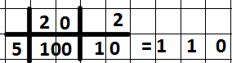  Expanded Method (formal)  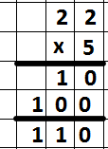
Stage 4  Know by heart times tables up to 12 × 12  Recognise factors up to 12 of 2-digit numbers  Multiply whole numbers and 1-place decimals by 10, 100, 1000  Multiply multiples of 10, 100 and 1000 by 1-digit numbers  e.g. 300 × 6  e.g. 4000 × 8  Use understanding of place value and number facts in mental multiplication  e.g. 36 × 5 is half of 36 × 10  e.g. 50 × 60 = 3000  Partition 2-digit numbers to multiply by a 1-digit number mentally  e.g. 4 × 24 as 4 × 20 and 4 × 4  Multiply near multiples by rounding  e.g. 33 × 19 as (33 × 20) – 33  Find doubles to double 100 and beyond using partitioning  Begin to double amounts of money  e.g. £35·60 doubled is £71·20 | 222 x 5 =  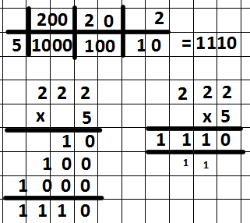  Compact

The Grid Method
When using the grid method children partition numbers in order to break multiplication into stages hence making it easier.
4 x 38 =
30 8 30 8
4 120 32 Here the children multiply 4 x 30 followed by 4 x 8
The final stage is to add the numbers together, they can do this using the column method or partitioning; 120 + 32 = 152

120 + 32 or 120
100 20 0 30 2 +32
100 50 2 = 152 152

The Expanded Column Method
When using the expanded column method the children will continue to use their knowledge of place value to multiply the units and then the tens.
3 8
x 4
3 2 Children will multiply 4 x 8
1 2 0 They will then multiply 4 x 30 =
1 5 2 The final stage of the calculation is to add the two numbers to find the total.

The Compact Column Method
When children are confident with place value and the expanded method they begin to use formal methods of calculation where they carry hundreds and tens underneath their answer.
3 8
x 4
1 ³5 2

It is important to note that although 5 x 3 = 15 and 3 x 5 = 15 are the same when discussing with the children then first number in the calculation is the number of groups. The second number being the quantity within each group. Eg. 5 x 3 is 5 groups of 3, the repeated addition would therefore be 3+3+3+3+3

